How can I sign up to volunteer – Coach/Assistant Coach
- You can sign up to volunteer while you are registering your child.
- During the registration process, select the appropriate program and role that you would like to sign up for and enter all required information.
- If you did not sign up to volunteer while registering your child, you can sign up at a later date.
- Log in to your account and click on the Volunteer tab >> and then click on Add Remove Volunteer Roles.
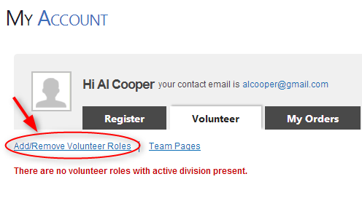
- Select the program, division, and role that you wish to sign up for, hit Next, and enter all required information.
- Once you are a volunteer, the role will display in your account like the image below:
